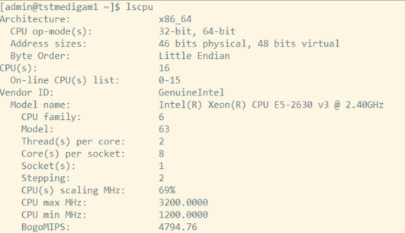

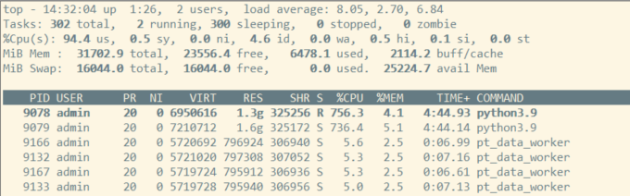

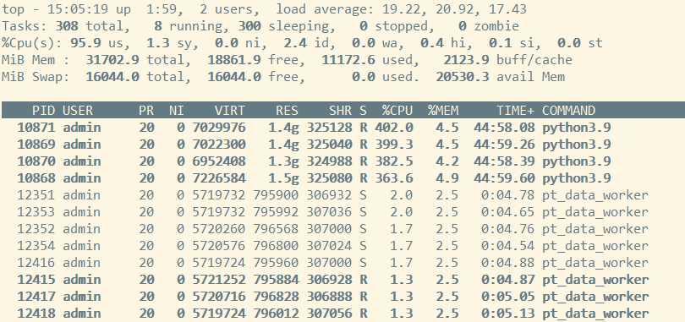
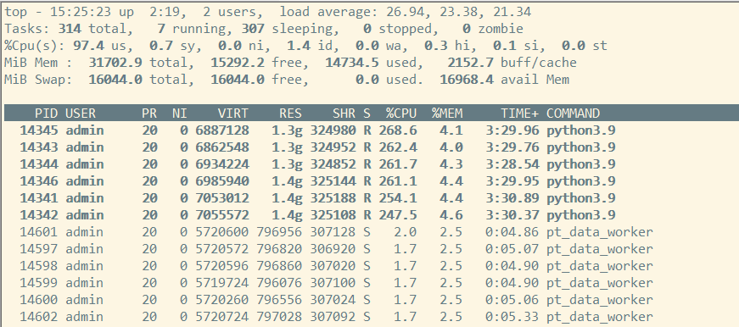

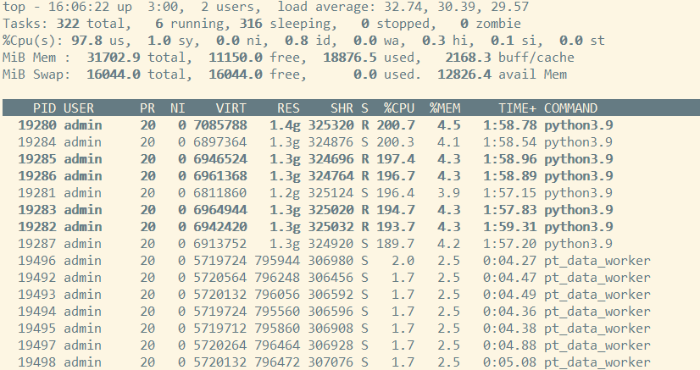
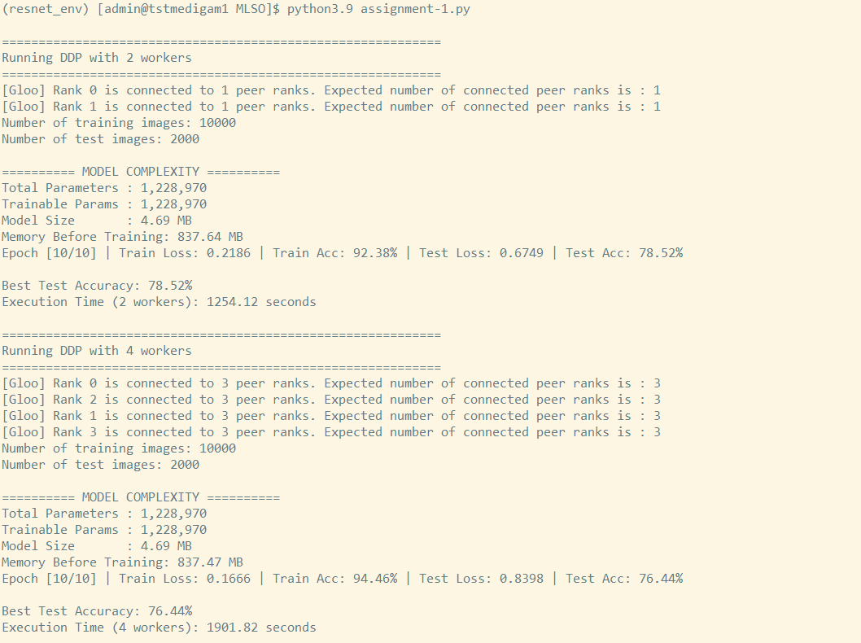

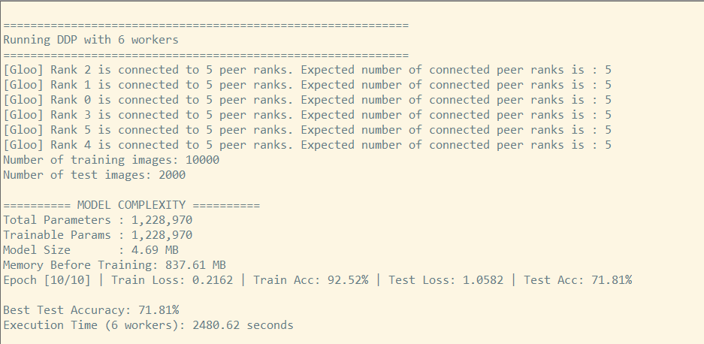
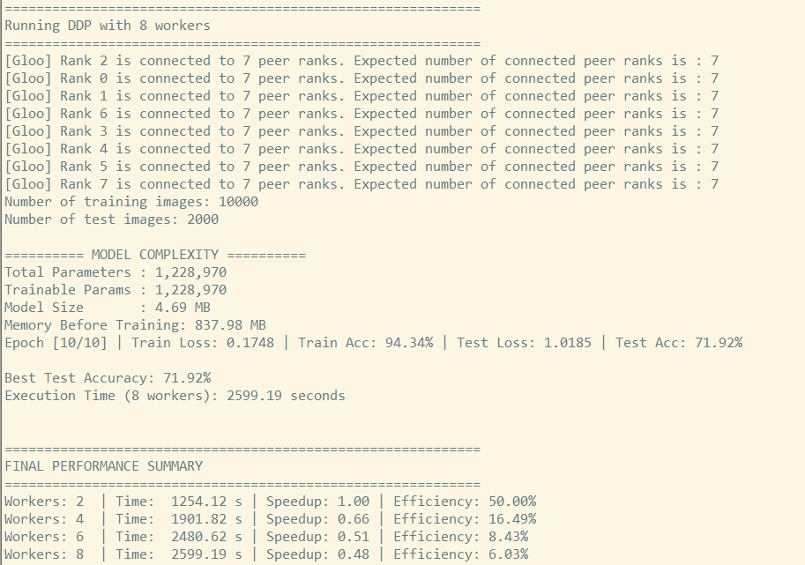

============================================================
Running DDP with 2 workers
============================================================
[Gloo] Rank 0 is connected to 1 peer ranks. Expected number of connected peer ranks is : 1
[Gloo] Rank 1 is connected to 1 peer ranks. Expected number of connected peer ranks is : 1
Number of training images: 10000
Number of test images: 2000

========== MODEL COMPLEXITY ==========
Total Parameters : 1,228,970
Trainable Params : 1,228,970
Model Size : 4.69 MB
Memory Before Training: 837.64 MB
Epoch [10/10] | Train Loss: 0.2186 | Train Acc: 92.38% | Test Loss: 0.6749 | Test Acc: 78.52%

Best Test Accuracy: 78.52%
Execution Time (2 workers): 1254.12 seconds

============================================================
Running DDP with 4 workers
============================================================
[Gloo] Rank 0 is connected to 3 peer ranks. Expected number of connected peer ranks is : 3
[Gloo] Rank 2 is connected to 3 peer ranks. Expected number of connected peer ranks is : 3
[Gloo] Rank 1 is connected to 3 peer ranks. Expected number of connected peer ranks is : 3
[Gloo] Rank 3 is connected to 3 peer ranks. Expected number of connected peer ranks is : 3
Number of training images: 10000
Number of test images: 2000

========== MODEL COMPLEXITY ==========
Total Parameters : 1,228,970
Trainable Params : 1,228,970
Model Size : 4.69 MB
Memory Before Training: 837.47 MB
Epoch [10/10] | Train Loss: 0.1666 | Train Acc: 94.46% | Test Loss: 0.8398 | Test Acc: 76.44%

Best Test Accuracy: 76.44%
Execution Time (4 workers): 1901.82 seconds

============================================================
Running DDP with 6 workers
============================================================
[Gloo] Rank 2 is connected to 5 peer ranks. Expected number of connected peer ranks is : 5
[Gloo] Rank 1 is connected to 5 peer ranks. Expected number of connected peer ranks is : 5
[Gloo] Rank 0 is connected to 5 peer ranks. Expected number of connected peer ranks is : 5
[Gloo] Rank 3 is connected to 5 peer ranks. Expected number of connected peer ranks is : 5
[Gloo] Rank 5 is connected to 5 peer ranks. Expected number of connected peer ranks is : 5
[Gloo] Rank 4 is connected to 5 peer ranks. Expected number of connected peer ranks is : 5
Number of training images: 10000
Number of test images: 2000

========== MODEL COMPLEXITY ==========
Total Parameters : 1,228,970
Trainable Params : 1,228,970
Model Size : 4.69 MB
Memory Before Training: 837.61 MB
Epoch [10/10] | Train Loss: 0.2162 | Train Acc: 92.52% | Test Loss: 1.0582 | Test Acc: 71.81%

Best Test Accuracy: 71.81%
Execution Time (6 workers): 2480.62 seconds

============================================================
Running DDP with 8 workers
============================================================
[Gloo] Rank 2 is connected to 7 peer ranks. Expected number of connected peer ranks is : 7
[Gloo] Rank 0 is connected to 7 peer ranks. Expected number of connected peer ranks is : 7
[Gloo] Rank 1 is connected to 7 peer ranks. Expected number of connected peer ranks is : 7
[Gloo] Rank 6 is connected to 7 peer ranks. Expected number of connected peer ranks is : 7
[Gloo] Rank 3 is connected to 7 peer ranks. Expected number of connected peer ranks is : 7
[Gloo] Rank 4 is connected to 7 peer ranks. Expected number of connected peer ranks is : 7
[Gloo] Rank 5 is connected to 7 peer ranks. Expected number of connected peer ranks is : 7
[Gloo] Rank 7 is connected to 7 peer ranks. Expected number of connected peer ranks is : 7
Number of training images: 10000
Number of test images: 2000

========== MODEL COMPLEXITY ==========
Total Parameters : 1,228,970
Trainable Params : 1,228,970
Model Size : 4.69 MB
Memory Before Training: 837.98 MB
Epoch [10/10] | Train Loss: 0.1748 | Train Acc: 94.34% | Test Loss: 1.0185 | Test Acc: 71.92%

Best Test Accuracy: 71.92%
Execution Time (8 workers): 2599.19 seconds

============================================================
FINAL PERFORMANCE SUMMARY
============================================================
Workers: 2 | Time: 1254.12 s | Speedup: 1.00 | Efficiency: 50.00%
Workers: 4 | Time: 1901.82 s | Speedup: 0.66 | Efficiency: 16.49%
Workers: 6 | Time: 2480.62 s | Speedup: 0.51 | Efficiency: 8.43%
Workers: 8 | Time: 2599.19 s | Speedup: 0.48 | Efficiency: 6.03%

